**CAR SALES SQL QUERIES**

**A. KPI’s**

**1. Sum of Sales**

**E:\new1\1.png**

*Output:*

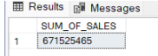

**2. Average of Sales**

**E:\new1\2.png**

*Output:*

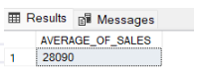

**3. Total Car Counts**

**E:\new1\3.png**

*Output:*

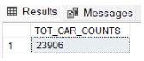

**4. Count of Sales by Car Model**

**E:\new1\4.png**

*Output:*

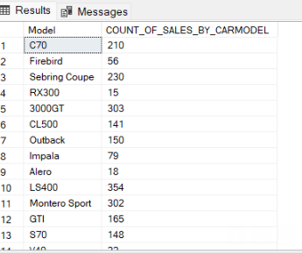

**5. Car Sales by Specific Model**

**E:\new1\5.png**

*Output:*

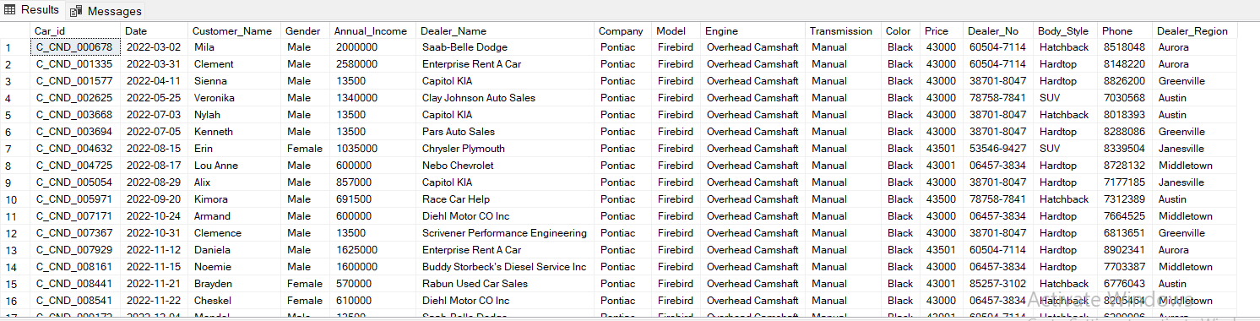

**6. Highest Price of Car sales**

***E:\new1\6.png***

*Output:*

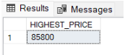

**7. Car Sales by Specific price Range**

***E:\new1\7.png***

*Output:*

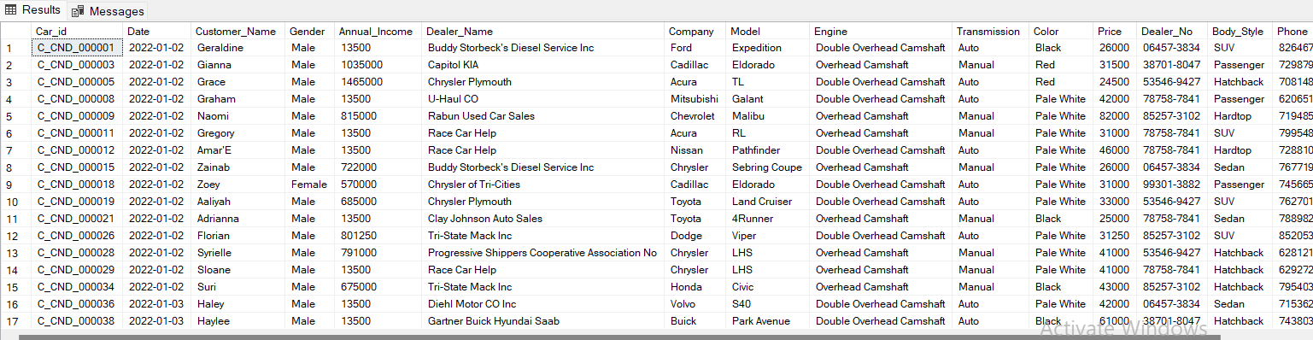

**8. Total Number of Cars Bought by Specific Gender**

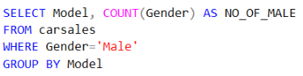

*Output:* 

**9. Month Wise Total Sales on Car Model**

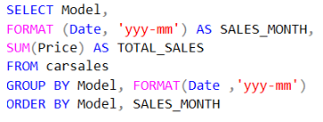

*Output:*

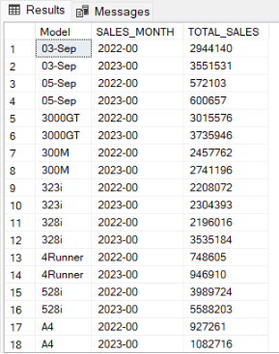

**10. Number of Sales by Dealer Region and Car Model**

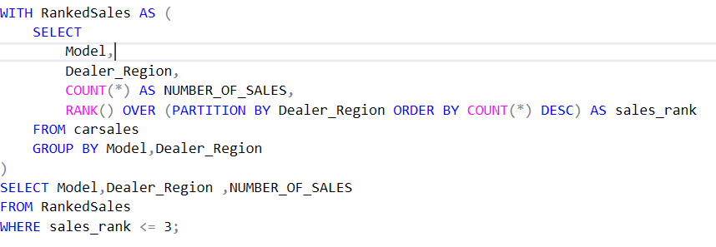

*Output:*

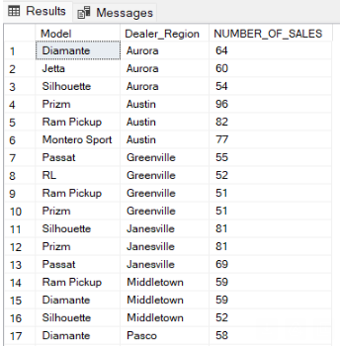

**11. Total Sales by Dealer Region**

E:\new1\11.png

*Output:*

